**Data Quality Report**

**Machine Predictive Maintenance Classification**

* SPSS Audit Report:

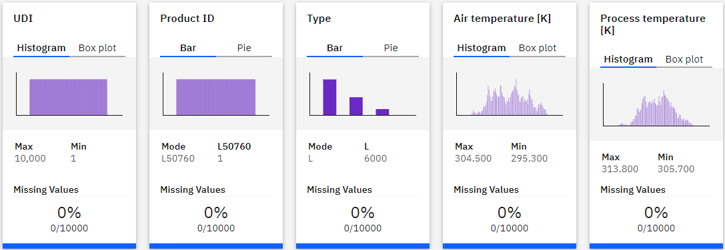

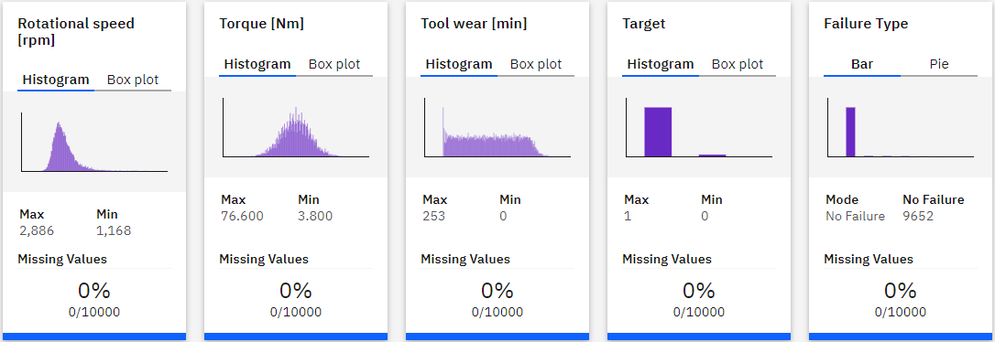

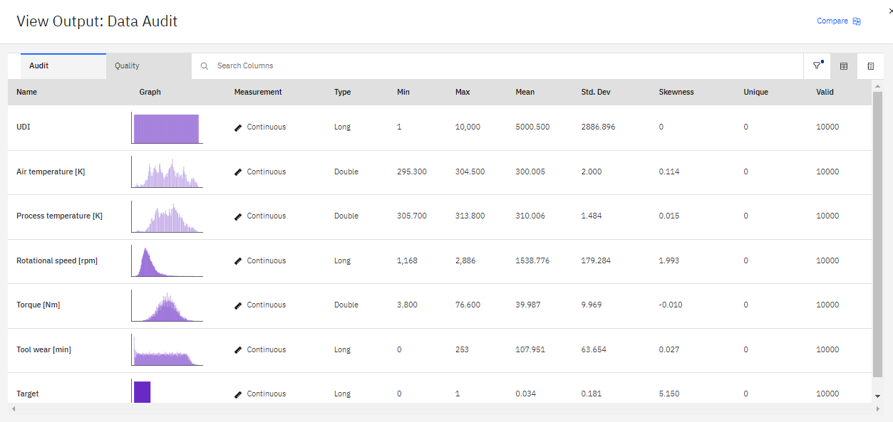

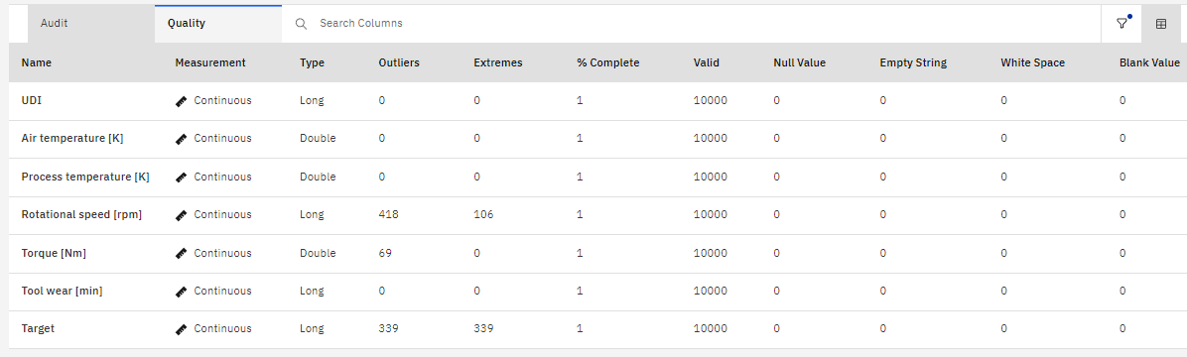

* **Missing Attributes and Blank Fields**

None of the attributes have missing or blanks values.

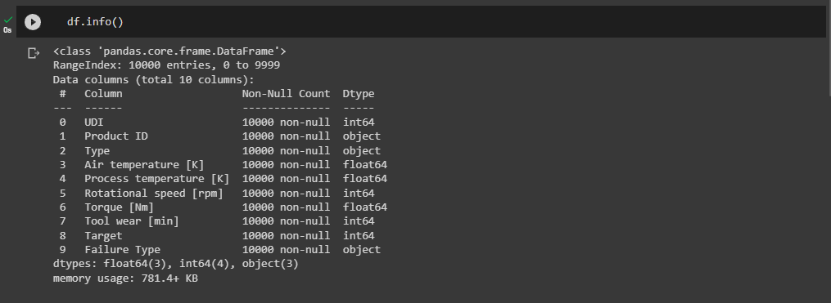

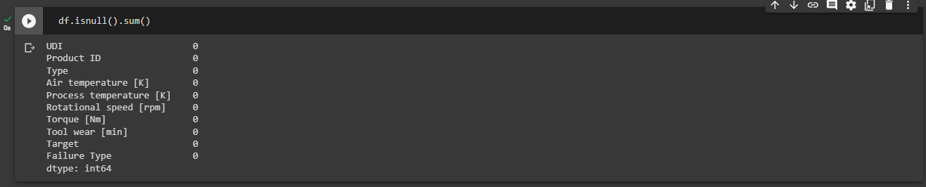

* **Spelling Inconsistencies**

None of the attributes have spelling inconsistencies.

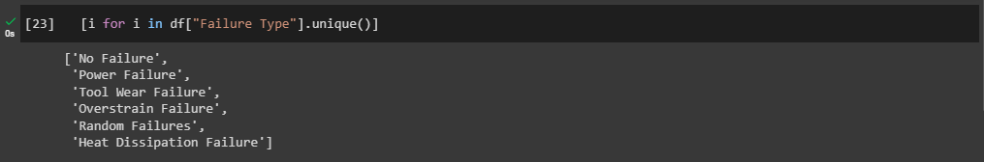

no spelling inconsistencies

* **Noise Analysis**

We can observe that there is a 415 outlier in ***Rotational Speed* .** But could be due to heat and differences in efficiency of model. And skews data at a ***Rotational Speed*** of about 1.993. We can also see in the image that the means and the median is 1538.77 and 1503 respectively.

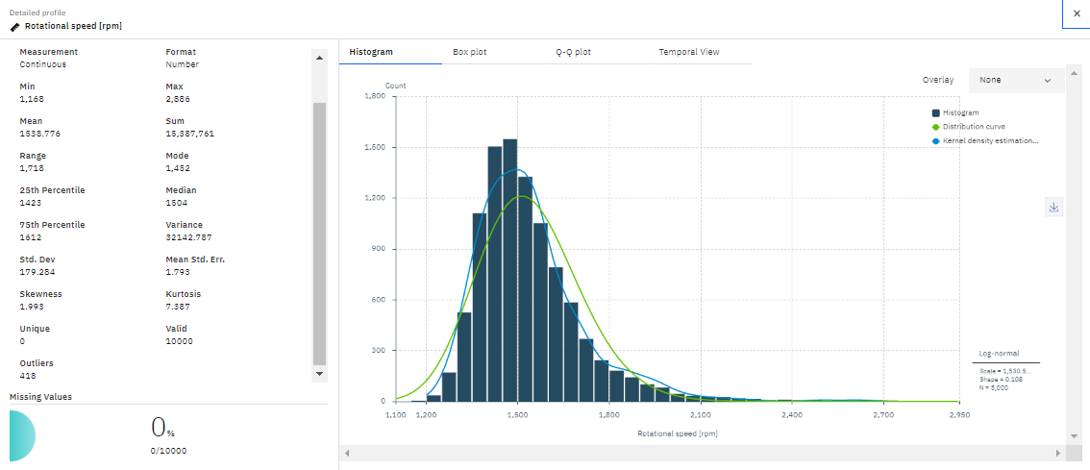

In Torque, we can also observe that there are outliers of about 69. It has a mean of 39.9, a median is 40.1 which is slightly left-skewed from the mean. But it will not affect the result.

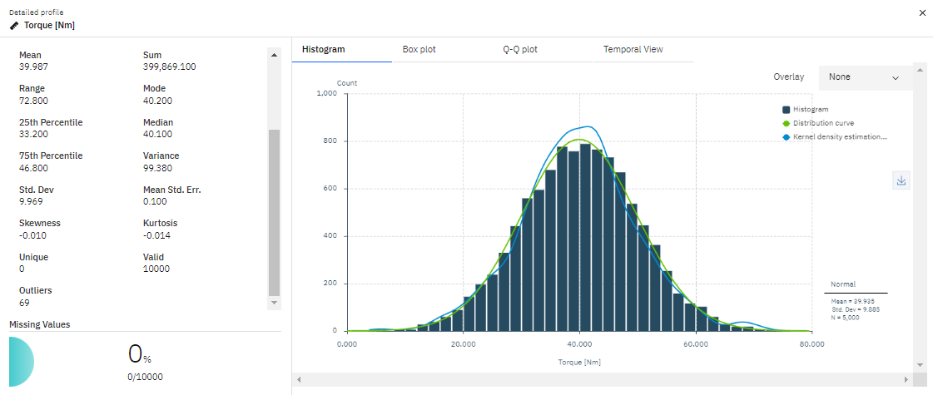

* **Plausibility check**

There was no plausibility for any of the attributes.

There was chance for ***Torque*** vs ***Rotational Speed,*** but we can see that it was inversely proportional to each other.

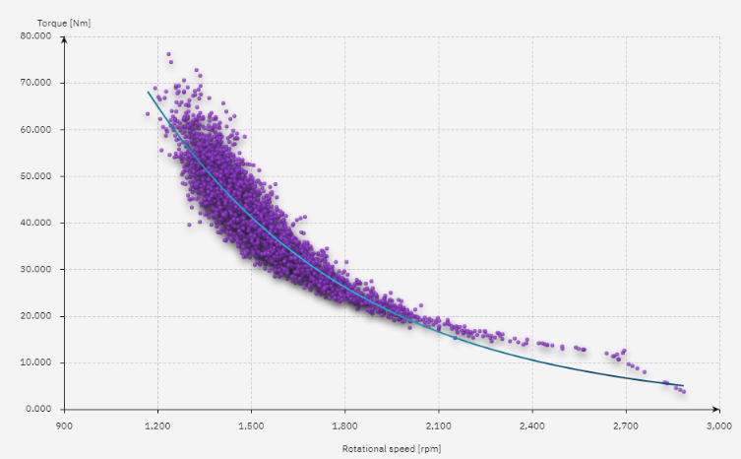

Relational Scatter Graph

* **Effect Of Excluding data/Attributes**

We can exclude the Attributes from UID or Product ID as they are not impact on hypothesis.

* **Data Format/Delimiter**

Data stored in CSV format.

All the delimiters are consistent among the files.

Each Records contains the same number of fields.